Image Processing:
There are a total of 70 Blocks in our workspace. 3 blocks of each of the alphabets from A to U. V and Y has 2 blocks each and rest have one blocks.
The position of each block is fixed in the workspace. It means that each and every block has its own unique position and hence each and every block has to be recognized by a unique number.
Suppose all 3 A’s have the same QR Code. A counter is kept to count the number of A’s detected. In the AVR the code is written such that when 1st A is detected it will keep at the first position, when 2nd A is detected it will keep at second position and finally 3rd A. The problem arises because of a very fast Image Processing. It is so much fast that as soon as it detects the first A it sends it to AVR and at the same time itself it takes the same block as the second A. So for only one block of A, 2 A’s are recognized and counter is incremented by 2. Though the bot will pick the block and place it at the position of first instance of A. Since counter is incremented by 2 now only 1 block of A can be recognized. Sometimes a case might arise in which all 3 A’s will be recognized on same block itself and counter will be incremented by 3.
That is the reason why we kept a unique QR Code for each block. Each unique QR code represents a unique position in the workspace. The QR codes are numbered from 00 to 69. So when 00 is sent to AVR it will have its own array and the position of the motors corresponding to that number will be selected and robot will move accordingly.
So the task of Image Processing is to recognize these numbers from 00 to 69 and send it serially to arduino.
There are 3 modes of operation:
- Setup Mode:
In This mode there will be a fixed area given to each block. Suppose a rectangle is drawn at any arbitrary position in workspace. The supervisor over there will just pick up all the blocks and place all those 70 blocks inside that rectangle. Inside the rectangle the position of each blocks will also be fixed. It means that you know where is he going to place the first A, second A and so on. The robot will go first to the position where first A is placed. At this point start your image processing. And verify whether the QR code detected at that position is “00” or not. If it is present send message to AVR that everything is fine you can pick it up. If the block is not present or if some other block say “01” is present send message to AVR that block “00” is not present and ask it to stop the robot there itself. On the GUI generate an error message saying “The block A is not present at the correct position. Verify the block number an place accordingly.”

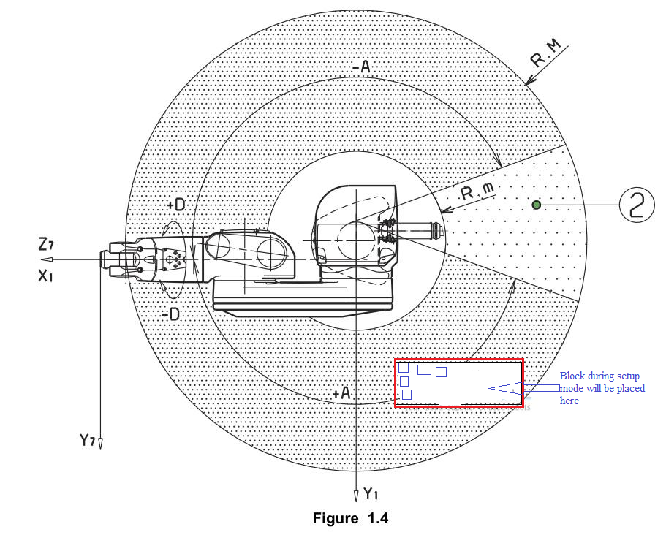

- User Mode:
This mode will always be executed when all the blocks are at the correct places in the workspace. The user enters a word. Each alphabet in the assigned its own value. Count the instance of each alphabet present in the string. Suppose I type “ABCDEFG”. A should be assigned 00, B=03, C= 06, D=09 and so on. Now suppose if I type “AABCDBE” then A = 00, A = 01, B = 03, C = 06, D = 09, B = 04 E = 12. Now send the first character that is “00” to AVR. The AVR will go to the position where “00” was placed. Now start Image Processing and check whether “00” is present below or not. If it is present tell AVR to go ahead and complete the pick and place process. Now the robot is at the destination1 position. Now send the second alphabet that is “03= B” to the AVR. Suppose block is not present. Check whether the required number of A’s is not 3. If it is 3 flash an error message on screen saying block A is not properly placed in workspace. If required number of A’s is 2 or 1 then goto the position of “01” again check whether 01 is present below or not and repeat the same process.
Finally you will be done with pick and place operation from source to destination. Now you need to bring all blocks back. Goto destination 1 position turn on Image processing and send whatever is detected to AVR. If “01”is detected send it to AVR so that robot keeps everything back. Process is completed when each block is placed back to their respective positions.

- Testing Mode:
In this mode we provide an option to the admin to test the camera and the motors whether they are working fine or not. When he clicks the camera button in the testing mode GUI a message will be sent to AVR to bring it to a pre-defined fixed position where a QR code will always be present. Lets say we have stick a QR code at that position which on detection says Test. As soon as the robot reaches that position Image Processing should turn on and camera must recognize the string Test. If it matches camera is working fine.

Now, for QR code detection I used ZBar Module. The installation and usage of which I have shown you previously. On the dropbox I have uploaded the code for a basic bar code detector which gives output as a string from the detected QR code. So the main task of image processing will be firstly to adjust the camera exactly below the gripper, cut the camera frame such that it captures no other content except the one which is below gripper.
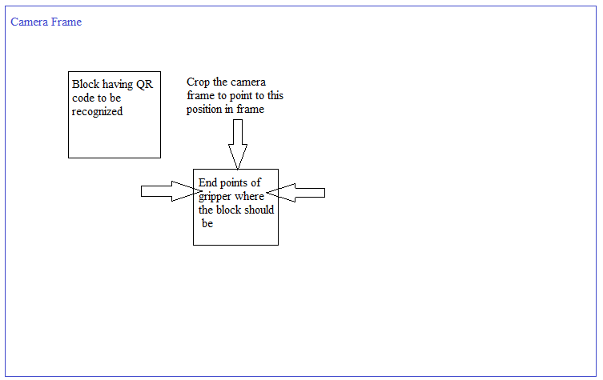
Consider the above case. The QR code will be recognized but the block is somewhere else in the camera frame. So crop the camera frame so that it can see only that part which is exactly below gripper.
Now scan that part using ZBar module. And send whatever is detected to AVR.

